**Database design for an Event management system**

OBJECTIVE:

Database design for an event management application, where user can create, access and register for any event that is occurring at the university.

This design supports the following features-

* User will be able to sign up/login for the application with user id and password along with personal details such as First name, Last name, Email ID, campus details and so on.
* User (with admin permissions) will be able to create an event and store the details such as event name, venue, date and time, price of the ticket etc .
* User will be able to search the list of events occurring in the university.
* User will be able to register for events, purchase one or more tickets for events.

PROBLEM STATEMENT:

* University has multiple clubs and they host many events throughout the academic year.
* It is in-efficient and time consuming to find about each and every event to students.
* Event organizers find it hard to keep track of list of attendees, payment status.

PROPOSED SOLUTION:

* Database model is developed to address above problems where the stakeholders (students and event organizers) can sign up for the application to access details about all the events that are taking place in the university.
* This model has entities such as Users, Organizers, Events, event types, Registrations and Payment.
* Using our database design, users who are organizers can create an event, retrieve the list of events, update the details for the existing event, delete the events.
* Users (students) can register using their Northeastern email id, create their profile and access the list of events and details about them.
* Registration and payment status are stored and maintained on each transaction.

DATA MODEL E-R DIAGRAM:

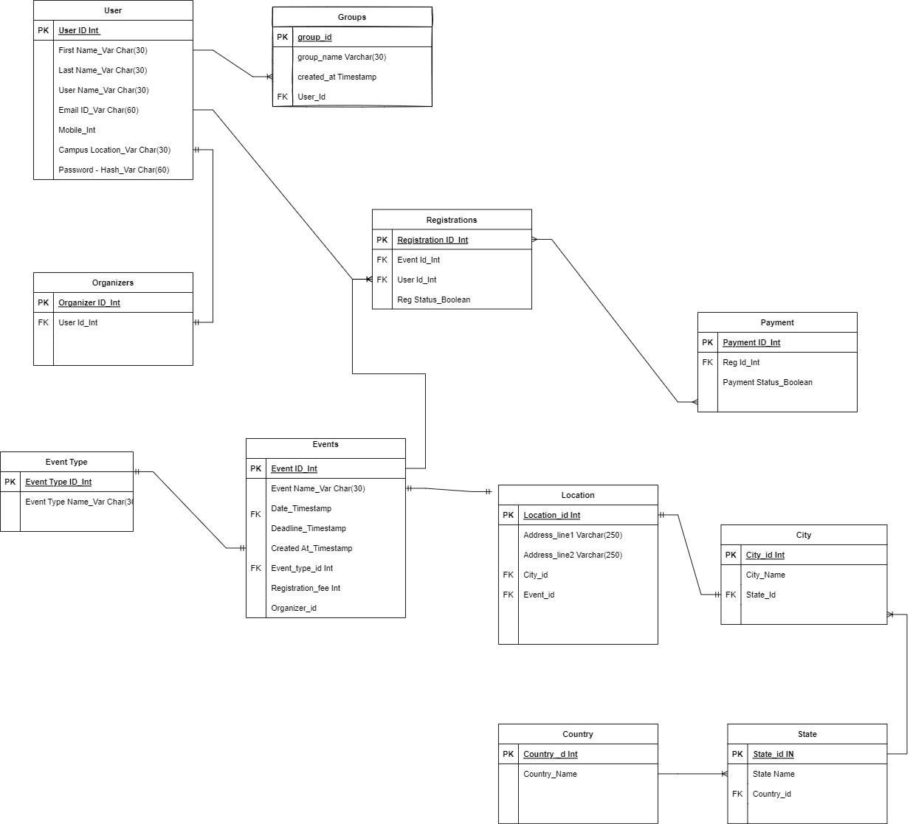

**USER ENTITY**

|  |  |  |
| --- | --- | --- |
| **ATTRIBUTES** | **DATA TYPE AND SIZE** | **COMMENTS** |
|  |  |  |
| USER_ID | INTEGER | PRIMARY KEY, AUTO GENERATED |
|  |  |  |
| USERNAME | VARCHAR (16) | UNIQUE KEY, NOT NULL |
|  |  |  |
| EMAIL | VARCHAR (60) | UNIQUE KEY, NOT NULL |
|  |  |  |
| PASSWORD | VARCHAR (15) | NOT NULL |
|  |  |  |
| DATE_JOINED | TIMESTAMP | CURRENT_TIMESTAMP |
|  |  |  |
| FIRST_NAME | VARCHAR (45) | NOT NULL |
|  |  |  |
| LAST_NAME | VARCHAR (45) | NOT NULL |
|  |  |  |
| PHONE_NUMBER | INTEGER | NOT NULL |
|  |  |  |

(NEED TO ADD ALL ENTITY DETAILS )

**EVENT ENTITY**

|  |  |  |
| --- | --- | --- |
| **ATTRIBUTES** | **DATA TYPE AND SIZE** | **COMMENTS** |
|  |  |  |
| USER_ID | INTEGER | PRIMARY KEY, AUTO GENERATED |
|  |  |  |
| USERNAME | VARCHAR (16) | UNIQUE KEY, NOT NULL |
|  |  |  |
| EMAIL | VARCHAR (60) | UNIQUE KEY, NOT NULL |
|  |  |  |
| PASSWORD | VARCHAR (15) | NOT NULL |
|  |  |  |
| DATE_JOINED | TIMESTAMP | CURRENT_TIMESTAMP |
|  |  |  |
| FIRST_NAME | VARCHAR (45) | NOT NULL |
|  |  |  |
| LAST_NAME | VARCHAR (45) | NOT NULL |
|  |  |  |
| PHONE_NUMBER | INTEGER | NOT NULL |
|  |  |  |